**1. What has ears but can not hear?**

/wɒt/ /hæz/ /ɪərz//bʌt//kæn//hɪər/?

Đáp án : Corn /kɔːn/ (an ear of com /æn//ɪər/ /əv/ /kɒm/: 1 bắp ngô)

**2. What clothing is always sad?**

/wɒt/ /ˈkləʊ.ðɪŋ//ɪz//ˈɔːl.weɪz//sæd/

Đáp án : Blue jeans /bluː/ /dʒiːnz/ (Blue còn là từ thể hiện tâm trạng buồn)

**3. What key does not lock the door?**

/wɒt//kiː//dʌz//nɒt//lɒk//ðiː//dɔːr/?

Đáp án : Key words /kiː/ /wɜːdz/

**4. Where does June come before May?**

/weər/ /dʌz/ /dʒuːn/ /kʌm/ /bɪˈfɔːr/ /meɪ/

Đáp án : Dictionary /ˈdɪk.ʃən.ər.i/

**5. What comes twice in a moment, once in a minute and never in a hundred years?**

/wɒt//kʌmz//twaɪs//ɪn/ /ə/ /ˈməʊ.mənt/, /wʌns//ɪn/ /ə/ /ˈmɪn.ɪt/ /ænd/ /ˈnev.ər/ /ɪn/ /ə/ /ˈhʌn.drəd/ /jɪərz/

Đáp án : Letter “M”

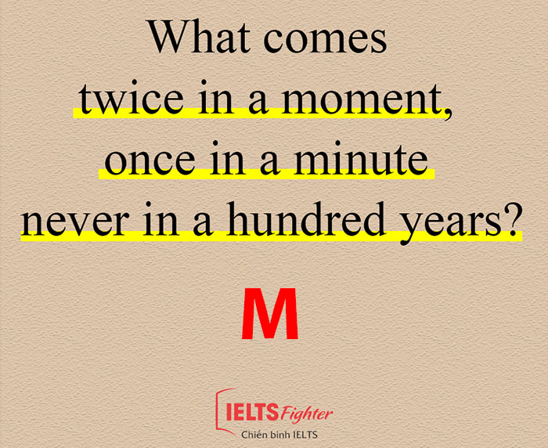

**6. What is it that was the past of tomorrow and the future of yesterday?**

/wɒt/ /ɪz//ɪt//ðæt//wɒz//ðiː/ /pɑːst/ /əv/ /təˈmɒr.əʊ//ænd//ðiː//ˈfjuː.tʃər//əv/ /ˈjes.tə.deɪ/

Đáp án : Today /təˈdeɪ/ (ngày hôm nay)

**7. What belongs only to you but it is used more by others than by yourself?**

/wɒt//bɪˈlɒŋz//ˈəʊn.li//tuː//juː//bʌt/ /ɪt//ɪz/ /juːst/ /mɔːr//baɪ/ /ˈʌð•ərz//ðæn//baɪ//jɔːˈself/?

Đáp án : Your name (tên của bạn) /jɔːr/ /neɪm/

**8. What increases but never decreases?**

/wɒt/ /ɪnˈkriːss/ /bʌt/ /ˈnev.ər/ /dɪˈkriːss/

Đáp án : Your age (tuổi tác)/jɔːr//eɪdʒ/

**9. Which months have the 28th day?**

/wɪtʃ/ /mʌnθs//hæv/ /ðiː/28th /deɪ/

Đáp án : All months (tất cả các tháng) /ɔːl/ /mʌnθs/

**10. What are the two things that people never eat before breakfast?**

/wɒt/ /ɑːr/ /ðiː//tuː/ /θɪŋz/ /ðæt/ /ˈpiː.pəl//ˈnev.ər//iːt//bɪˈfɔːr/ /ˈbrek.fəst/

Đáp án : Lunch and Dinner  /lʌntʃ/ /ænd/ /ˈdɪn.ər/

**11. Who works only one day in a year but never gets fired?**

/huː/ /wɜrks/ /ˈəʊn.li/ /wʌn/ /deɪ//ɪn/ /ə/ /jɪər//bʌt//ˈnev.ər/ /ɡets/ /faɪərd/

Đáp án : Santa Claus /ˈsæn.tə ˌklɔːz/

**12. What has three hands but only one face?**

/wɒt/ /hæz/ /θriː/ /hændz//bʌt/ /ˈəʊn.li//wʌn//feɪs/

Đáp án : A clock /ə/ /klɒk/

**13. When I eat, I live but when I drink, I die. Who am I?**

/wen/ /aɪ/ /iːt/,/aɪ//lɪv/ /bʌt//wen/ /aɪ//drɪŋk//daɪ/. /huː/ /æm//aɪ/?

Đáp án : Fire (lửa)/faɪər/

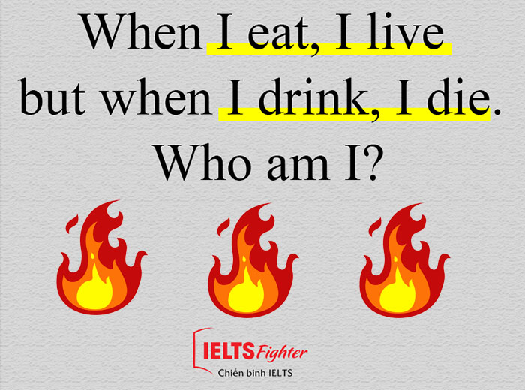

**14. They travel all over the world but end up in one corner. What are they?**

/ðeɪ/ /ˈtræv.əl/ /ɔːl/ /ˈəʊ.vər/ /ðiː//wɜːld//bʌt/ /end//ʌp//ɪn/ /wʌn/ /ˈkɔː.nər/. /wɒt/ /ɑːr/ /ðeɪ/?

Đáp án : Stamps /stæmps/

**15. What kind of cup can't hold water**

/wɒt//kaɪnd/ /əv/ /kʌp/ /kænt/ /həʊld/ /ˈwɔː.tər/

Đáp án : a cupcake /ə/ /ˈkʌp.keɪk/

**16. What bank never has any money**

/wɒt//bæŋk/ /ˈnev.ər/ /hæz/ /ˈen.i/ /ˈmʌn.i/

Đáp án : the riverbank /ðiː/ /ˈrɪvəˌbæŋk/

**17. What ship has two mates but no captain?**

/wɒt//ʃɪp/ /hæz/ /tuː/ /meɪts//bʌt//nəʊ/ /ˈkæp.tɪn/

Đáp án : a relationship /ə/ /rɪˈleɪ.ʃən.ʃɪp/

**18. What comes down but never goes up**

/wɒt//kʌmz/ /daʊn/ /bʌt/ /ˈnev.ər//ɡəʊz/ /ʌp/

Đáp án : Rain /reɪn/

**19. What is the longest word in the dictionary**

/wɒt/ /ɪz/ /ðiː//lɒŋɪst//wɜːd//ɪn//ðiː/ /ˈdɪk.ʃən.ər.i/

Đáp án : Smiles /smaɪlz/

**20. How can somebody walk for 8 days without sleeping**

/haʊ/ /kæn/ /ˈsʌm.bə.di/ /wɔːk//fɔːr/ /eɪt/ /deɪz/

Đáp án : He sleeps only at night /hiː//sliːps//ˈəʊn.li/ /æt/ /naɪt/

**21. What has three ways out and just one way in?**

/wɒt/ /hæz/ /θriː/ /weɪz//aʊt/ /ænd/ /dʒʌst/ /wʌn/ /weɪ/ /ɪn/

Đáp án : A t-shirt /ə/ /ˈtiː ʃɜːt/

**22. I have every color but no gold. What am I**

/aɪ/ /həv/ /ˈevri//ˈkʌlə(r)/ /bʌt//nəʊ/ /ɡəʊld/.  /wɒt/ /æm//aɪ/?

Đáp án : a rainbow /ə/ /ˈreɪnbəʊ/

**23. What goes through towns and over hills but never moves?**

/wɒt/ /ɡəʊz/ /θruː/ /taʊnz//ænd//hɪlz//bʌt//ˈnev.ər//muːvz/

Đáp án : A road /ə/ /rəʊd/

**24. Take off my skin - I won't cry but you will. What am I?**

/teɪk//ɒf/ /maɪ/ /skɪn/ /aɪ/ /wəʊnt/ /kraɪ/ /bʌt/ /juː/ /wɪl/. /wɒt//æm//aɪ/?

Đáp án : An onion /ən//ˈʌnjən/

**25. Which word contains 26 letters but only syllables?**

/wɪtʃ//wɜːd/ /kənˈteɪnz/ 26 /ˈletə(r)z//bʌt/ /ˈəʊn.li//ˈsɪləbls/

Đáp án : alphabet /ˈælfəbet/

**26. I can fly but have no wings.I can cry but I have no eyes. Wherever I go, darkness follows me. What am I?**

/aɪ//kən/ /flaɪ/ /bʌt/ /həv//nəʊ//wɪŋs/. /aɪ/ /kən/ /kraɪ/ /bʌt/ /aɪ/ /həv/ /nəʊ/ /aɪz/. /weərˈevə(r)/ /aɪ//ɡəʊ/, /ˈdɑːknəs/ /ˈfɒləʊz//mi/./wɒt//æm//aɪ/?

Đáp án : Clouds /klaʊdz/  
  
**27. Which word in the English language is most frequently spelled wrong?**

/wɪtʃ//wɜːd//ɪn/ /ðiː/ /ˈɪŋɡlɪʃ/ /ˈlæŋɡwɪdʒ/ /ɪz/ /məʊst//ˈfriːkwəntli/ /speld//rɒŋ/?

Đáp án : wrong /rɒŋ/

**28. What walks on four legs in the morning, two legs at midday, and three legs in the evening?**

/wɒt//wɔːks//ɒn/ /fɔː(r)/ /leɡz//ɪn//ðiː/ /ˈmɔːnɪŋ/, /tuː/ /leɡz/ /ət/ /ˌmɪdˈdeɪ/ /ænd/ /θriː/ /leɡz/ /ɪn//ðiː/ /ˈiːvnɪŋ/

Đáp án: Man /mæn/

**29. What tastes better than it smells?**

Đáp án: A Tongue.

**30. What kind of room has no doors or windows?**

Đáp án: A Mushroom.

**31. During what month do people sleep the least?**

Đáp án: February, it's the shortest month.

**32. What is orange and sounds like a parrot?**

Đáp án: A Carrot.

**33.  What word becomes shorter when you add two letters to it?**

Đáp án: Short

**34. Two children are born on the same day by the same mother but they are not twins. How is that possible?**

Đáp án: They are triplets!

**35.  Henry's mother had three children. The first child was named Spring, The second child was named Winter. What was the third child's name?**

Đáp án: Henry of course.

**36. What has four wheels and flies?**

Đáp án: A garbage truck.

**37. What gets wetter the more it dries?**

Đáp án: A towel.

**38. Which word in the dictionary is spelled incorrectly?**

Đáp án: Incorrectly

**39. You cannot keep this until you have given it. What is it?**

Đáp án: A promise.

**40. What spends all the time on the floor but never gets dirty?**

Đáp án: Your Shadow.

**41. What part of the chicken has the most feathers?**

Đáp án: The Outside.

**42. What goes up and down but never moves?**

Đáp án:The stairs.

**43. What sounds like a sneeze and is made out of leather?**

Đáp án: A shoe

**44. What always goes to sleep with shoes on?**

Đáp án: A horse

**45.  What has a bottom at the top?**

Đáp án: Your legs.

**46. If two is company and three is a crowd, what is four and five?**

Đáp án: Nine of course.

**47. What starts with an E, ends with an E and only has one letter in it?**

Đáp án: An envelope

**48. What runs but never walks?**

Đáp án: A tap.

**49. What is a chickens favourite vegetable?**

Đáp án: An eggplant.

**50. What kind of vegetable needs a plumber?**

Đáp án: A Leek.

**51.  If Y.E.S spells "yes", what does E.Y.E.S spell?**

 works best when said to a friend and not read

**52. How far can a bear walk into the woods?**

Đáp án:  Halfway.

**53. Which 5 letter words in the dictionary can be pronounced the same, even if it has 4 of its letters removed?**

Đáp án:  Queue

**54. What is something that you can easily hold in your right hand but never in your left hand?**

Đáp án:  Your left elbow.

**55.  Which word in the dictionary starts and finishes with the letter E, but only has one letter?**

Đáp án:  Envelope.

**56. What has a neck but doesn't have a head?**

Đáp án: A bottle.

**57. What begins with the letter P, finishes with the letter E and has over a thousand letters in it?**

Đáp án:  Post Office.

**58. If everyone decided to purchase only pink cars, what would we have?**

Đáp án: A pink carnation.

**59. What is so unbelievably fragile that just by speaking it's name will break it?**

Đáp án: Silence.

**60. Walk on the living, they don't even mumble. Walk on the dead and they mutter and grumble. What are they?**

Đáp án: Leaves

**61. There are 10 kids and a bowl with 10 oranges in it. How do divide up the oranges so that every kid gets and orange but one remains in the bowl?**

Đáp án: You give 9 kids an orange each and you give the tenth kid the bowl with the orange in it.

**62. A young man is learning to drive. He travels the wrong way down a one way street and passes a policeman. The policeman sees him but does nothing. Why?**

Đáp án:  The young man was walking.

**63. What starts with a T, ends with a T and is full of T?**

Đáp án: A Teapot.

**64. I am weightless, but put me in a bucket and I will make it lighter. What am I?**

Đáp án: A hole.

**65. What has many hearts but no other organs?**

Đáp án: A deck of cards.

**66. What sometimes freezes after it has been heated up?**

Đáp án: A computer.

**67. Plucked from a fruit, bitter like a root, burning and bold, or even cold when sold. What am I?**

Đáp án: Coffee beans.

**68. There are two monkeys on a tree and one jumps off. Why does the other monkey jump too?**

Đáp án: Monkey see monkey do.

**69. What is always in front of you but can’t be seen?**

Đáp án:  The future

**70. What question can you never answer yes to?**

Đáp án: Are you asleep yet?

**71. I’m tall when I’m young, and I’m short when I’m old. What am I?**

Đáp án: A candle

**72. A man dies of old age on his 25 birthday. How is this possible?**

Đáp án:  He was born on February 29.

**73. The more of this there is, the less you see. What is it?**

Đáp án: Darkness

**74. Riddle: What has lots of eyes, but can’t see?**

Đáp án: A potato

**75. Riddle: What has one eye, but can’t see?**

Đáp án: A needle

**76. Riddle: What has many needles, but doesn’t sew?**

Đáp án:  A Christmas tree

**77. What has hands, but can’t clap?**

Đáp án: A clock

**79. What has legs, but doesn’t walk?**

Đáp án: A table

**80. What has one head, one foot and four legs?**

Đáp án: A bed

**81. What can you catch, but not throw?**

Đáp án: A cold

**82. What kind of band never plays music?**

Đáp án: A rubber band

**83. What has many teeth, but can’t bite?**

Đáp án: A comb

**85. What is cut on a table, but is never eaten?**

Đáp án: A deck of cards

**86.  Riddle: What has words, but never speaks?**

Đáp án: A book

**87. What runs all around a backyard, yet never moves?**

Đáp án: A fence

**88. What can travel all around the world without leaving its corner?**

Đáp án: A stamp

**89. What has a thumb and four fingers, but is not a hand?**

Đáp án: A glove

**90. What has a head and a tail but no body?**

Đáp án: A coin

**91. Where does one wall meet the other wall?**

Đáp án: On the corner

**92. What building has the most stories?**

Đáp án: The library

**93. What tastes better than it smells?**

Đáp án: Your tongue

**94. What has 13 hearts, but no other organs?**

Đáp án: A deck of cards

**95. What kind of coat is best put on wet?**

Đáp án: A coat of paint

**96. What has a bottom at the top?**

Đáp án: Your legs

**97. What has four wheels and flies?**

Đáp án: A garbage truck

**98. I am an odd number. Take away a letter and I become even. What number am I?**

Đáp án: Seven

**99. If two’s company, and three’s a crowd, what are four and five?**

Đáp án: Nine

**100. What three numbers, none of which is zero, give the same result whether they’re added or multiplied?**

Đáp án: One, two and three

**101.Three doctors said that Bill was their brother. Bill says he has no brothers. How many brothers does Bill actually have?**

Đáp án: None. He has three sisters.

**102. Two fathers and two sons are in a car, yet there are only three people in the car. How?**

Đáp án: They are a grandfather, father and son.

**103. The day before yesterday I was 21, and next year I will be 24. When is my birthday?**

Đáp án: December 31; today is January 1.

**104. A little girl goes to the store and buys one dozen eggs. As she is going home, all but three break. How many eggs are left unbroken?**

Đáp án:  Three

**105. If there are three apples and you take away two, how many apples do you have?**

Đáp án: You have two apples.

**106. What five-letter word becomes shorter when you add two letters to it?**

Đáp án: Short

**107. What begins with an “e” and only contains one letter?**

Đáp án: An envelope

**108. What would you find in the middle of Toronto?**

Đáp án: The letter “o”

**109. You see me once in June, twice in November and not at all in May. What am I?**

Đáp án: The letter “e”

**110. Two in a corner, one in a room, zero in a house, but one in a shelter. What is it?**

Đáp án: The letter “r”

**111. I am the beginning of everything, the end of everywhere. I’m the beginning of eternity, the end of time and space. What am I?**

Đáp án: Also the letter “e”

**112.  What 4-letter word can be written forward, backward or upside down, and can still be read from left to right?**

Đáp án: NOON

**113.  Forward I am heavy, but backward I am not. What am I?**

Đáp án: The word “not”

**114. What is 3/7 chicken, 2/3 cat and 2/4 goat?**

Đáp án: Chicago

**115. I am a word of letters three; add two and fewer there will be. What word am I?**

Đáp án: Few

**116. What word of five letters has one left when two are removed?**

Đáp án: Stone

**117. What is the end of everything?**

Đáp án: The letter “g”

**118. What word is pronounced the same if you take away four of its five letters?**

Đáp án: Queue

**119. What can run but never walks, has a mouth but never talks, has a head but never weeps, has a bed but never sleeps?**

Đáp án: A river

**120. Speaking of rivers, a man calls his dog from the opposite side of the river. The dog crosses the river without getting wet, and without using a bridge or boat. How?**

Đáp án: The river was frozen.

**121. What can fill a room but takes up no space?**

Đáp án: Light

**122. If you drop me I’m sure to crack, but give me a smile and I’ll always smile back. What am I?**

Đáp án: A mirror

**123. The more you take, the more you leave behind. What are they?**

Đáp án: Footsteps

**124. People make me, save me, change me, raise me. What am I?**

Đáp án:  Money

**125. What breaks yet never falls, and what falls yet never breaks?**

Đáp án: Day, and night

**126. What goes through cities and fields, but never moves?**

Đáp án: A road

**127. I have lakes with no water, mountains with no stone and cities with no buildings. What am I?**

Đáp án: A map

**128. What does man love more than life, hate more than death or mortal strife; that which contented men desire; the poor have, the rich require; the miser spends, the spendthrift saves, and all men carry to their graves?**

Đáp án: Nothing